* **JQuery Basic, Effects & Advance**

**•** What is JQuery?

* JQuery is a lightweight, "write less, do more", JavaScript library. The purpose of JQuery is to make it much easier to use JavaScript on your website.

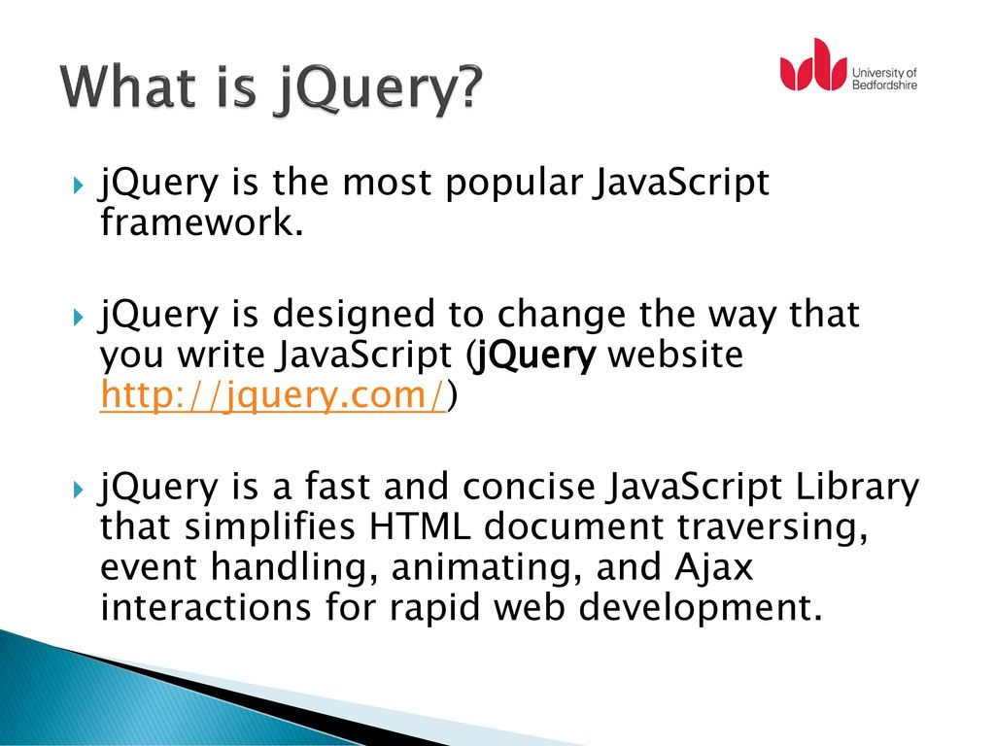

• How to Apply CSS Using JQuery, How to Add Class and Remove Class in JQuery, JQuery Animation?

* jQuery Manipulating CSS
* addClass() - Adds one or more classes to the selected elements.
* removeClass() - Removes one or more classes from the selected elements.
* toggleClass() - Toggles between adding/removing classes from the selected elements.
* css() - Sets or returns the style attribute.

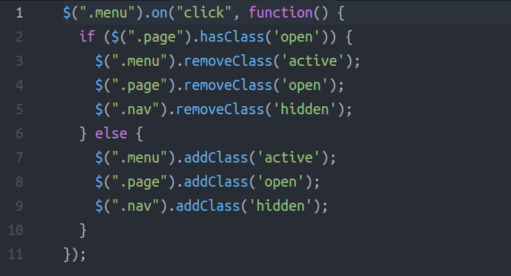

• How to create slider with animation?

* Step 1: Come up with a strategy for the slider. You can make as many modifications as you want to Slider Revolution templates. ...

Step 2: Update the background image in each slide. ...

Step 3: Update the text layers in each slide. ...

Step 4: Edit the button text and design in each slide. ...

Step 5: Edit the slider navigation.

 C:\Users\Sandeep\Desktop\biju\jquery assingment.html